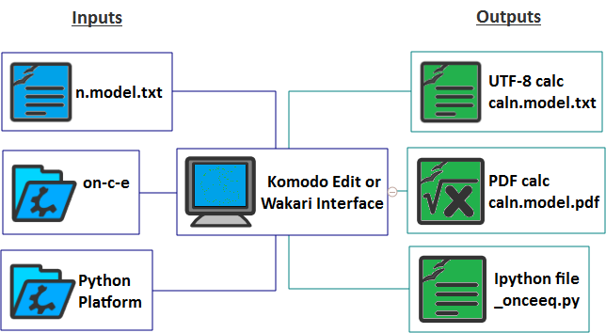
Komodo Edit or Wakari Interface
- UTF-8 calc caln.model.txt
- PDF calc caln.model.pdf
- Ipython file _onceeq.py
- Python Platform
- on-c-e
- n.model.txt
- Inputs
- Outputs

